# Patient

## Signout

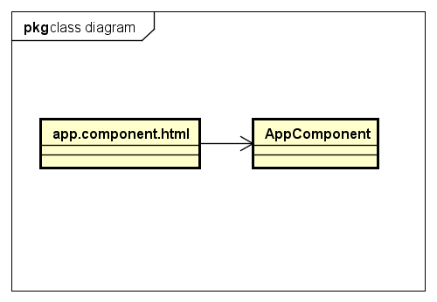

* app.component.html

Refer to UI design

* AppComponent

|  |  |  |  |
| --- | --- | --- | --- |
| **Attribute** | | | |
| No. | Name | Type | Description |

|  |  |  |  |  |
| --- | --- | --- | --- | --- |
| **Method** | | | | |
| No. | Name | Params | Return type | Description |
| 1 | signout |  | void | Sign patient out |

## Forgot-pwd

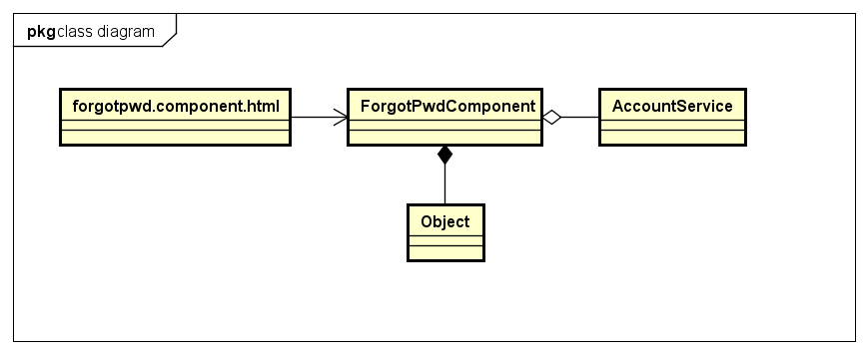

* forgotpwd.component.html

Refer to UI design

* ForgotPwdComponent

|  |  |  |  |
| --- | --- | --- | --- |
| **Attribute** | | | |
| No. | Name | Type | Description |
| 1 | forgotForm | FormGroup | FormGroup instance for submitting email |
| 2 | submitForm | FormGroup | FormGroup instance for submitting new password |
| 3 | submitAttempt | boolean | Indicate user pressed submit button |
| 4 | submitting | boolean | Indicate data is being saved |
| 5 | messageNoti | string | Message to notify user |

|  |  |  |  |  |
| --- | --- | --- | --- | --- |
| **Method** | | | | |
| No. | Name | Params | Return type | Description |
| 1 | sendRequestChangingPassword | data: any,  valid: boolean | void | Request change password |
| 2 | sendNewPassword |  | void | Send code to change password |

* AccountService

|  |  |  |  |
| --- | --- | --- | --- |
| **Attribute** | | | |
| No. | Name | Type | Description |

|  |  |  |  |  |
| --- | --- | --- | --- | --- |
| **Method** | | | | |
| No. | Name | Params | Return type | Description |
| 1 | requestChangePassword | email: string | Observable | Request to change password |
| 2 | changePassword | token: string,  password: string | Observable | Change to new password |

* Object (Javascript object)

## Search doctors

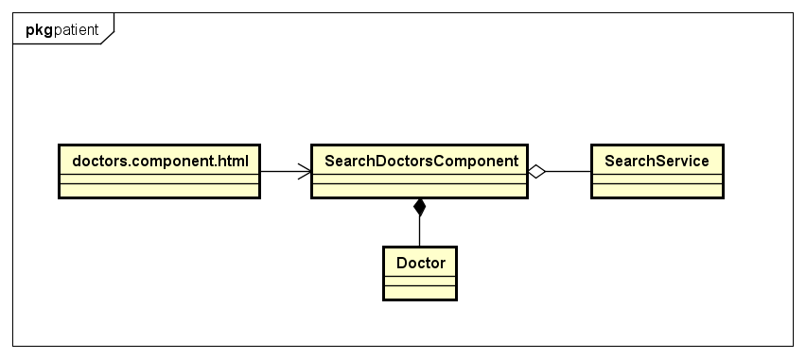

* doctors.component.html

Refer to UI design

* SearchDoctorsComponent

|  |  |  |  |
| --- | --- | --- | --- |
| **Attribute** | | | |
| No. | Name | Type | Description |
| 1 | matchingDoctors | Doctor[] | Store current matching doctors |

|  |  |  |  |  |
| --- | --- | --- | --- | --- |
| **Method** | | | | |
| No. | Name | Params | Return type | Description |
| 1 | searchDoctors | data: any | void | Send request/ Remove request relationship based on context |

* AccountService

|  |  |  |  |
| --- | --- | --- | --- |
| **Attribute** | | | |
| No. | Name | Type | Description |

|  |  |  |  |  |
| --- | --- | --- | --- | --- |
| **Method** | | | | |
| No. | Name | Params | Return type | Description |
| 1 | searchDoctor | name: string,  specialtyID: string,  country: string,  city: string | Observable | Send request get doctors with specific conditions |

* Doctor

|  |  |  |  |
| --- | --- | --- | --- |
| **Attribute** | | | |
| No. | Name | Type | Description |
|  | Id | string | Identify for doctor |
|  | firstName | string | First name of doctor |
|  | lastName | string | Last name of doctor |
|  | fullname | string | Full name of doctor |
|  | email | string | Email of doctor |
|  | password | string | Password of doctor |
|  | dob | string | Day of birth |
|  | sex | number | Sex of doctor |
|  | phone | string | Phone of doctor |
|  | role | number | Role of doctor in system |
|  | status | number | Status of doctor’s account |
|  | address | string | Address of doctor |
|  | photo | string | Photo of doctor |
|  | created | string | Time at doctor account created |
|  | lastModified | string | Last time doctor account is modified |
|  | rank | number | Rank of doctor |
|  | specialty | Specialty | Specialty of doctor |
|  | place | Place | Place where doctor work |
|  | noOfVoters | Number | Number of patient who commented |
|  | attachment | string | Attachment of doctor |

|  |  |  |  |  |
| --- | --- | --- | --- | --- |
| **Method** | | | | |
| No. | Name | Params | Return type | Description |

## Chat

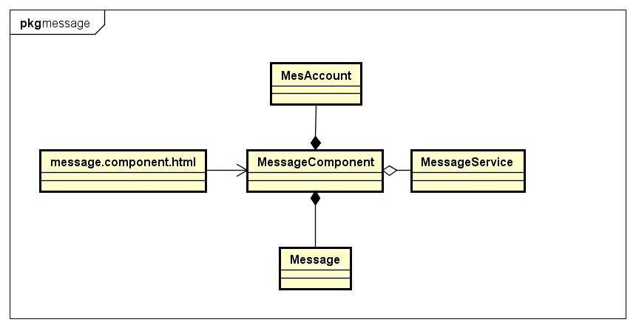

* message.component.html

Refer to UI design

* MessageComponent

|  |  |  |  |
| --- | --- | --- | --- |
| **Attribute** | | | |
| No. | Name | Type | Description |
| 1 | searchForm | FormGroup | FormGroup instance for searching partner |
| 2 | frelMesAccounts | MesAccount | Store account information with unseen message |
| 3 | viewingMessages | Message[] | Store messages with current partner |

|  |  |  |  |  |
| --- | --- | --- | --- | --- |
| **Method** | | | | |
| No. | Name | Params | Return type | Description |
| 1 | sendMessage |  | void | Send new message to partner |

* DoctorService

|  |  |  |  |
| --- | --- | --- | --- |
| **Attribute** | | | |
| No. | Name | Type | Description |

|  |  |  |  |  |
| --- | --- | --- | --- | --- |
| **Method** | | | | |
| No. | Name | Params | Return type | Description |
| 1 | createMessage | account: Account,  msg: Message | Observable | Send request to send new message |

* Message

|  |  |  |  |
| --- | --- | --- | --- |
| **Attribute** | | | |
| No. | Name | Type | Description |
|  | id | string | Identify of message |
|  | broadcaster | Account | User who send message |
|  | recipient | Account | User who received message |
|  | content | string | Content for appointment |
|  | isSeen | boolean | Indicate message is seen |
|  | created | string | Time at message is sent |

|  |  |  |  |  |
| --- | --- | --- | --- | --- |
| **Method** | | | | |
| No. | Name | Params | Return type | Description |

* MesAccount

|  |  |  |  |
| --- | --- | --- | --- |
| **Attribute** | | | |
| No. | Name | Type | Description |
|  | Id | string | Identify for medical category item |
|  | firstName | string | First name of doctor |
|  | lastName | string | Last name of doctor |
|  | fullname | string | Full name of doctor |
|  | email | string | Email of doctor |
|  | password | string | Password of doctor |
|  | dob | string | Day of birth |
|  | sex | number | Sex of doctor |
|  | phone | string | Phone of doctor |
|  | role | number | Role of doctor in system |
|  | status | number | Status of doctor account |
|  | address | string | Address of doctor |
|  | photo | string | Photo of doctor |
|  | created | string | Time at doctor account is created |
|  | lastModified | string | Last time doctor account is modified |
|  | unSeenMessages | Message[] | Unseen messages sent from this account |

|  |  |  |  |  |
| --- | --- | --- | --- | --- |
| **Method** | | | | |
| No. | Name | Params | Return type | Description |

## Settings

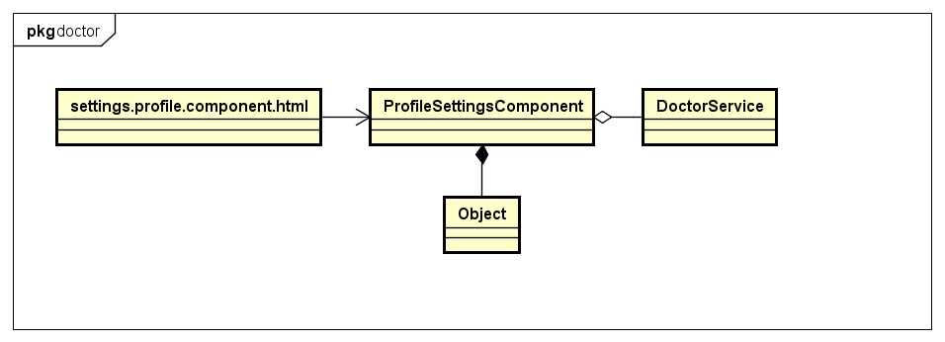

* settings.profile.component.html

Refer to UI design

* ProfileSettingsComponent

|  |  |  |  |
| --- | --- | --- | --- |
| **Attribute** | | | |
| No. | Name | Type | Description |
| 1 | pwdForm | FormGroup | FormGroup to update password |
| 4 | patient | Patient | Store current patient profile |
| 5 | patientProfileForm | FormGroup | FormGroup to update profile |

|  |  |  |  |  |
| --- | --- | --- | --- | --- |
| **Method** | | | | |
| No. | Name | Params | Return type | Description |
| 1 | changePassword | data: any,  valid: boolean | Void | Change password |
| 2 | saveProfilePhoto | file: Blob | void | Save new photo |
| 3 | updateDoctorProfile | data: any,  valid: boolean | boolean | Update profile |

* PatientService

|  |  |  |  |
| --- | --- | --- | --- |
| **Attribute** | | | |
| No. | Name | Type | Description |

|  |  |  |  |  |
| --- | --- | --- | --- | --- |
| **Method** | | | | |
| No. | Name | Params | Return type | Description |
| 1 | changeProfilePhoto | account: Account,  formData: FormData | Observable | Send request to update photo |
| 2 | updatePatientPassword | account: Account,  data: any | Observable | Send request to update password |
| 3 | updatePatientProfile | account: Account,  data: any | Observable | Send request to update profile |

* Object (Javascript Object)

## View appointment details

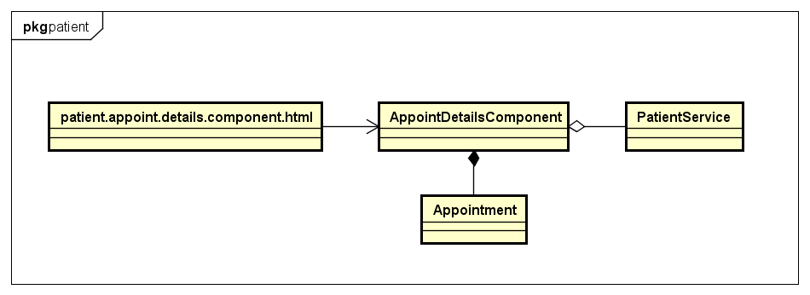

* patient.appointment.component.html

Refer to UI design

* AppointmentDetailsComponent

|  |  |  |  |
| --- | --- | --- | --- |
| **Attribute** | | | |
| No. | Name | Type | Description |
| 1 | appoint | Appointment | Appointment instance |
| 2 | showLoader | boolean | Show loading data progress |
| 3 | updatingAppoint | boolean | Show data is updating |
| 4 | noteForm | FormGroup | Store FormGroup instance for appointment action |
| 5 | submitAttemp | boolean | Indicate doctor pressed submit button |

|  |  |  |  |  |
| --- | --- | --- | --- | --- |
| **Method** | | | | |
| No. | Name | Params | Return type | Description |
| 1 | acceptAppointment |  | boolean | Accept appointment |
| 2 | cancelAppointment |  | Boolean | Cancel appointment |
| 3 | gotoEditAppointment |  | Boolean | Go to edit appointment |
| 4 | handleAcceptAppointment |  | void | Call function to open note modal for accepting appointment |
| 5 | handleCancelAppointment |  | void | Call function to open note modal for canceling appointment |
| 6 | proceedActionAppointment |  | boolean | Proceed accepting/canceling action |

* PatientService

|  |  |  |  |
| --- | --- | --- | --- |
| **Attribute** | | | |
| No. | Name | Type | Description |

|  |  |  |  |  |
| --- | --- | --- | --- | --- |
| **Method** | | | | |
| No. | Name | Params | Return type | Description |
| 1 | updateStatusAppointment | account: Account,  appoint: Appointment,  status: number,  note: string | Observable | Updating status of appointment |

* Appointment

|  |  |  |  |
| --- | --- | --- | --- |
| **Attribute** | | | |
| No. | Name | Type | Description |
|  | id | string | Identify of appointment |
|  | dater | Account | User who being asked for an appointment |
|  | maker | Account | User who created appointment |
|  | note | string | Note for appointment |
|  | additionalNote | string | Additional note for last action |
|  | date | string | Date of appointment |
|  | start | string | Start of appointment |
|  | end | string | End of appointment |
|  | status | number | Status of appointment |
|  | created | string | Time at appointment created |
|  | lastModified | string | Last time appointment modified |

|  |  |  |  |  |
| --- | --- | --- | --- | --- |
| **Method** | | | | |
| No. | Name | Params | Return type | Description |

## Edit appointment

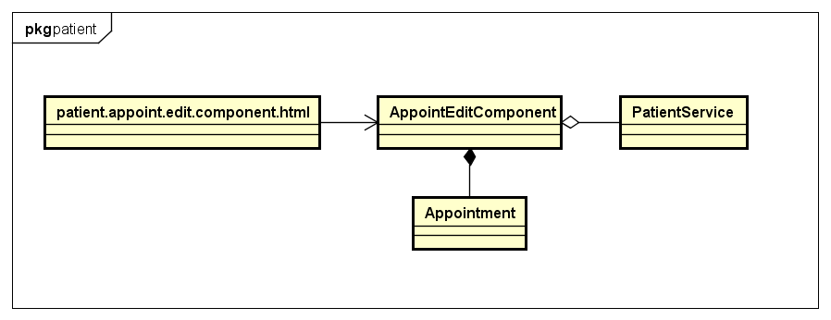

* patient.appoint.edit.component.html

Refer to UI design

* AppointmentEditComponent

|  |  |  |  |
| --- | --- | --- | --- |
| **Attribute** | | | |
| No. | Name | Type | Description |
| 1 | appointment | Appointment | Store appointment is editing |
| 2 | editForm | FormGroup | Editing formgroup |
| 3 | submitAttemp | boolean | Indicate whether user pressed submit button |
| 4 | savingAppointment | boolean | Indicate system is saving new data |
| 5 | showLoader | boolean | Indicate system is loading appointment details |

|  |  |  |  |  |
| --- | --- | --- | --- | --- |
| **Method** | | | | |
| No. | Name | Params | Return type | Description |
| 1 | saveAppointment | data: any  valid: boolean | boolean | Updating appointment |

* PatientService

|  |  |  |  |
| --- | --- | --- | --- |
| **Attribute** | | | |
| No. | Name | Type | Description |

|  |  |  |  |  |
| --- | --- | --- | --- | --- |
| **Method** | | | | |
| No. | Name | Params | Return type | Description |
| 1 | updateAppointment | account: Account,  model: Appointment | Observable | Updating appointment |

* Appointment

|  |  |  |  |
| --- | --- | --- | --- |
| **Attribute** | | | |
| No. | Name | Type | Description |
|  | id | string | Identify of appointment |
|  | dater | Account | User who being asked for an appointment |
|  | maker | Account | User who created appointment |
|  | note | string | Note for appointment |
|  | additionalNote | string | Additional note for last action |
|  | date | string | Date of appointment |
|  | start | string | Start of appointment |
|  | end | string | End of appointment |
|  | status | number | Status of appointment |
|  | created | string | Time at appointment created |
|  | lastModified | string | Last time appointment modified |

|  |  |  |  |  |
| --- | --- | --- | --- | --- |
| **Method** | | | | |
| No. | Name | Params | Return type | Description |

## Add appointment

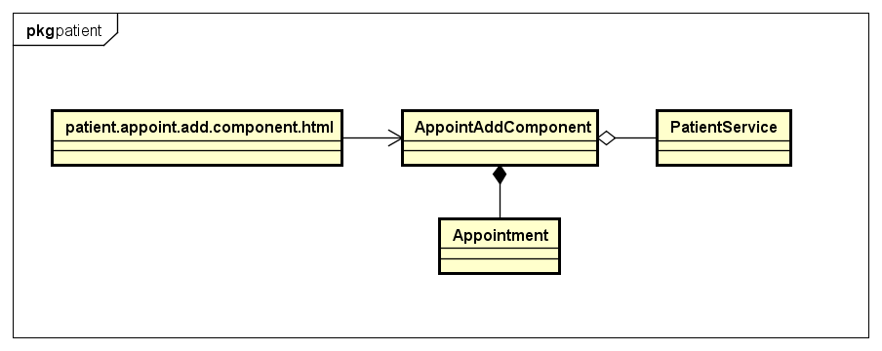

* patient.appointment.add.component.html

Refer to UI design

* AppointmentAddComponent

|  |  |  |  |
| --- | --- | --- | --- |
| **Attribute** | | | |
| No. | Name | Type | Description |
| 1 | model | Appointment | Store new appointment data |
| 2 | addForm | FormGroup | Adding formgroup |
| 3 | submitAttemp | boolean | Indicate whether user pressed submit button |
| 4 | savingAppointment | boolean | Indicate system is saving new data |

|  |  |  |  |  |
| --- | --- | --- | --- | --- |
| **Method** | | | | |
| No. | Name | Params | Return type | Description |
| 1 | saveNewAppointment | data: any  valid: boolean | boolean | Create new appointment |

* PatientService

|  |  |  |  |
| --- | --- | --- | --- |
| **Attribute** | | | |
| No. | Name | Type | Description |

|  |  |  |  |  |
| --- | --- | --- | --- | --- |
| **Method** | | | | |
| No. | Name | Params | Return type | Description |
| 1 | createNewAppointment | account: Account,  model: Appointment | Observable | Create appointment |

* Appointment

|  |  |  |  |
| --- | --- | --- | --- |
| **Attribute** | | | |
| No. | Name | Type | Description |
|  | id | string | Identify of appointment |
|  | dater | Account | User who being asked for an appointment |
|  | maker | Account | User who created appointment |
|  | note | string | Note for appointment |
|  | additionalNote | string | Additional note for last action |
|  | date | string | Date of appointment |
|  | start | string | Start of appointment |
|  | end | string | End of appointment |
|  | status | number | Status of appointment |
|  | created | string | Time at appointment created |
|  | lastModified | string | Last time appointment modified |

|  |  |  |  |  |
| --- | --- | --- | --- | --- |
| **Method** | | | | |
| No. | Name | Params | Return type | Description |

## View activated appointments

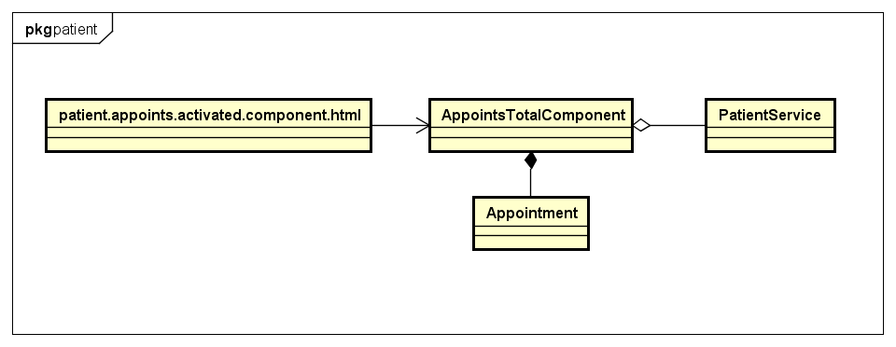

* patient.appoints.activated.component.html

Refer to UI design

* AppointsTotalComponent

|  |  |  |  |
| --- | --- | --- | --- |
| **Attribute** | | | |
| No. | Name | Type | Description |
| 1 | appoints | Appointment[] | Store all activated appointment |
| 2 | currentAppoints | Appointment[] | Store appointments in specific day |

|  |  |  |  |  |
| --- | --- | --- | --- | --- |
| **Method** | | | | |
| No. | Name | Params | Return type | Description |
| 1 | getAllAppointment |  | void | Get all activated appointment |

* PatientService

|  |  |  |  |
| --- | --- | --- | --- |
| **Attribute** | | | |
| No. | Name | Type | Description |

|  |  |  |  |  |
| --- | --- | --- | --- | --- |
| **Method** | | | | |
| No. | Name | Params | Return type | Description |
| 1 | getAllAppointments | account: Account | Observable | Get all activated appointment |

* Appointment

|  |  |  |  |
| --- | --- | --- | --- |
| **Attribute** | | | |
| No. | Name | Type | Description |
|  | id | string | Identify of appointment |
|  | dater | Account | User who being asked for an appointment |
|  | maker | Account | User who created appointment |
|  | note | string | Note for appointment |
|  | additionalNote | string | Additional note for last action |
|  | date | string | Date of appointment |
|  | start | string | Start of appointment |
|  | end | string | End of appointment |
|  | status | number | Status of appointment |
|  | created | string | Time at appointment created |
|  | lastModified | string | Last time appointment modified |

|  |  |  |  |  |
| --- | --- | --- | --- | --- |
| **Method** | | | | |
| No. | Name | Params | Return type | Description |

## View pending appointments

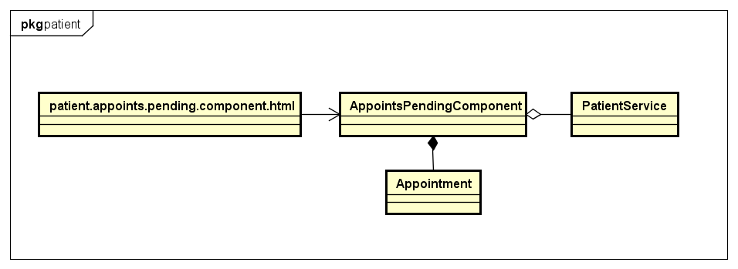

* patient.appoints.pending.component.html

Refer to UI design

* AppointsPendingComponent

|  |  |  |  |
| --- | --- | --- | --- |
| **Attribute** | | | |
| No. | Name | Type | Description |
| 1 | pendingAppoints | Appointment[] | Store all activated appointment |
| 2 | currentAppoints | Appointment[] | Store appointments in specific type |

|  |  |  |  |  |
| --- | --- | --- | --- | --- |
| **Method** | | | | |
| No. | Name | Params | Return type | Description |
| 1 | getAllAppointment |  | void | Get all activated appointment |
| 2 | acceptAppointment | appoint: Appointment,  note: string | boolean | Accept an appointment |
| 3 | cancelAppointment | appoint: Appointment,  note: string | boolean | Cancel an appointment |

* PatientService

|  |  |  |  |
| --- | --- | --- | --- |
| **Attribute** | | | |
| No. | Name | Type | Description |

|  |  |  |  |  |
| --- | --- | --- | --- | --- |
| **Method** | | | | |
| No. | Name | Params | Return type | Description |
| 1 | updateStatusAppointment | account: Account,  appoint: Appointment, status: number, note: string |  |  |

* Appointment

|  |  |  |  |
| --- | --- | --- | --- |
| **Attribute** | | | |
| No. | Name | Type | Description |
|  | id | string | Identify of appointment |
|  | dater | Account | User who being asked for an appointment |
|  | maker | Account | User who created appointment |
|  | note | string | Note for appointment |
|  | additionalNote | string | Additional note for last action |
|  | date | string | Date of appointment |
|  | start | string | Start of appointment |
|  | end | string | End of appointment |
|  | status | number | Status of appointment |
|  | created | string | Time at appointment created |
|  | lastModified | string | Last time appointment modified |

|  |  |  |  |  |
| --- | --- | --- | --- | --- |
| **Method** | | | | |
| No. | Name | Params | Return type | Description |

## Search appointments

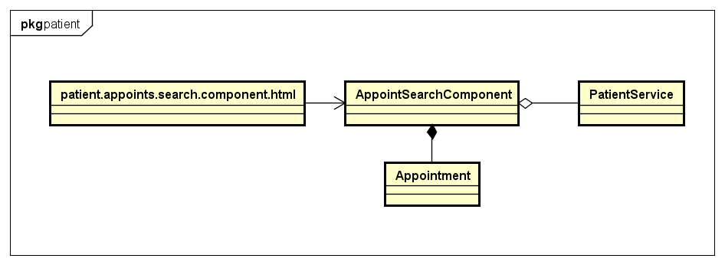

* patient.appoints.searching.component.html

Refer to UI design

* AppointsSearchingComponent

|  |  |  |  |
| --- | --- | --- | --- |
| **Attribute** | | | |
| No. | Name | Type | Description |
| 1 | appoints | Appointment[] | Store all activated appointment |
| 2 | searchForm | FormGroup | Formgroup instance for seaching |
| 3 | searchPressed | boolean | Indicate whether buttons seach has been pressed |
| 4 | showLoading | boolean | Indicate data is processing |

|  |  |  |  |  |
| --- | --- | --- | --- | --- |
| **Method** | | | | |
| No. | Name | Params | Return type | Description |
| 1 | getAllAppointment |  | void | Get all activated appointment |
| 2 | acceptAppointment | appoint: Appointment,  note: string | boolean | Accept an appointment |
| 3 | cancelAppointment | appoint: Appointment,  note: string | boolean | Cancel an appointment |

* PatientService

|  |  |  |  |
| --- | --- | --- | --- |
| **Attribute** | | | |
| No. | Name | Type | Description |

|  |  |  |  |  |
| --- | --- | --- | --- | --- |
| **Method** | | | | |
| No. | Name | Params | Return type | Description |
| 1 | getAllAppointments | account: Account,  start: number,  end: number | Observable | Get all pending appointments |

* Appointment

|  |  |  |  |
| --- | --- | --- | --- |
| **Attribute** | | | |
| No. | Name | Type | Description |
|  | id | string | Identify of appointment |
|  | dater | Account | User who being asked for an appointment |
|  | maker | Account | User who created appointment |
|  | note | string | Note for appointment |
|  | additionalNote | string | Additional note for last action |
|  | date | string | Date of appointment |
|  | start | string | Start of appointment |
|  | end | string | End of appointment |
|  | status | number | Status of appointment |
|  | created | string | Time at appointment created |
|  | lastModified | string | Last time appointment modified |

|  |  |  |  |  |
| --- | --- | --- | --- | --- |
| **Method** | | | | |
| No. | Name | Params | Return type | Description |

## View medical records

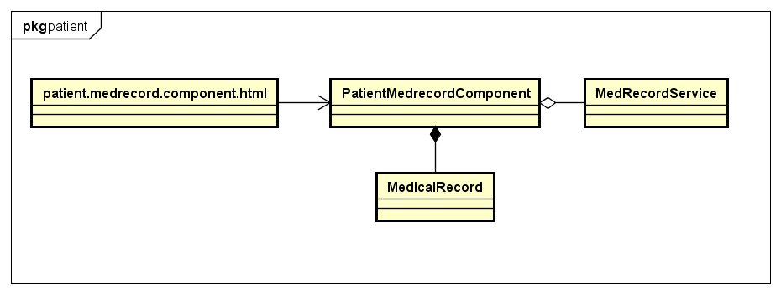

* patient.medrecord.component.html

Refer to UI design

* PatientMedrecordComponent

|  |  |  |  |
| --- | --- | --- | --- |
| **Attribute** | | | |
| No. | Name | Type | Description |
| 1 | medicalRecords | MedicalRecord[] | Store all medical records |
| 2 | filteredMedicalRecords | MedicalRecord[] | Store all medical records filter by category |
| 3 | filteredMedCategories | MedicalCategory[] | Store all medical categories |

|  |  |  |  |  |
| --- | --- | --- | --- | --- |
| **Method** | | | | |
| No. | Name | Params | Return type | Description |
| 1 | getAllMedicalRecords |  | void | Get all medical record created own by patient |

* MerecordService

|  |  |  |  |
| --- | --- | --- | --- |
| **Attribute** | | | |
| No. | Name | Type | Description |

|  |  |  |  |  |
| --- | --- | --- | --- | --- |
| **Method** | | | | |
| No. | Name | Params | Return type | Description |
| 1 | getAllMedicalRecords | account: Account | Observable | Send request to get all medical record own by patient |

* MedicalRecord

|  |  |  |  |
| --- | --- | --- | --- |
| **Attribute** | | | |
| No. | Name | Type | Description |
| 1 | id | string | Identity for medical record |
| 2 | owner | Account | Owner of medical record |
| 3 | creator | Account | Person who created this medical record |
| 4 | category | MedicalCategory | Medical category of medical record |
| 5 | name | string | Name of medical record |
| 6 | date | string | Date of medical record |
| 7 | info | Object | Specific information of patient |
| 8 | created | string | Time at medical record created |
| 9 | lastModified | string | Last time at medical record modified |

|  |  |  |  |  |
| --- | --- | --- | --- | --- |
| **Method** | | | | |
| No. | Name | Params | Return type | Description |

## Create medical record

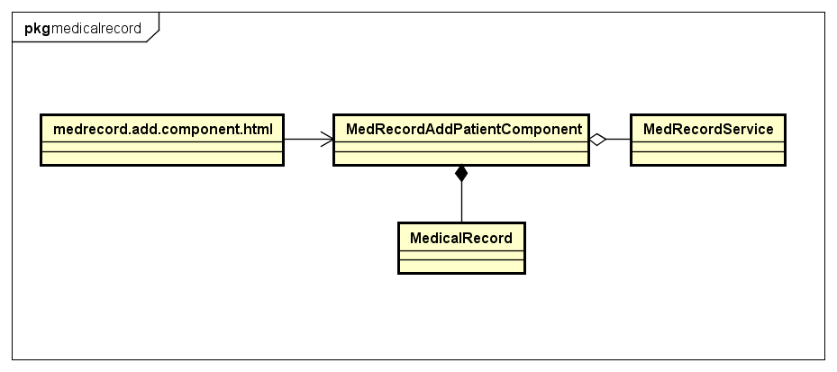

* Medrecord.add.component.html

Refer to UI design

* MedRecordAddPatientComponent

|  |  |  |  |
| --- | --- | --- | --- |
| **Attribute** | | | |
| No. | Name | Type | Description |
| 1 | model | MedicalRecord | Store new medical record data |
| 2 | medCategories | MedicalCategory[] | Store categories |
| 3 | savingMedicalRecord | boolean | Indicate medical record is creating |
| 4 | medrecordForm | FormGroup | FormGroup instance for creating medical record |
| 5 | medForms | FormGroup[] | FormGroup instances for creating medicines |
| 6 | submitAttempt | boolean | Indicate whether user pressed submit button |
| 7 | validFormAdd | boolean | Indicate form contains valid data |

|  |  |  |  |  |
| --- | --- | --- | --- | --- |
| **Method** | | | | |
| No. | Name | Params | Return type | Description |
| 1 | saveMedicalRecord | Data: any | void | Creating new medical record |

* MerecordService

|  |  |  |  |
| --- | --- | --- | --- |
| **Attribute** | | | |
| No. | Name | Type | Description |

|  |  |  |  |  |
| --- | --- | --- | --- | --- |
| **Method** | | | | |
| No. | Name | Params | Return type | Description |
| 1 | createMedicalRecord | account: Account,  model: MedicalRecord | Observable | Send request to create new medical record |

* MedicalRecord

|  |  |  |  |
| --- | --- | --- | --- |
| **Attribute** | | | |
| No. | Name | Type | Description |
| 1 | id | string | Identity for medical record |
| 2 | owner | Account | Owner of medical record |
| 3 | creator | Account | Person who created this medical record |
| 4 | category | MedicalCategory | Medical category of medical record |
| 5 | name | string | Name of medical record |
| 6 | date | string | Date of medical record |
| 7 | info | Object | Specific information of patient |
| 8 | created | string | Time at medical record created |
| 9 | lastModified | string | Last time at medical record modified |

|  |  |  |  |  |
| --- | --- | --- | --- | --- |
| **Method** | | | | |
| No. | Name | Params | Return type | Description |

## Edit medical record

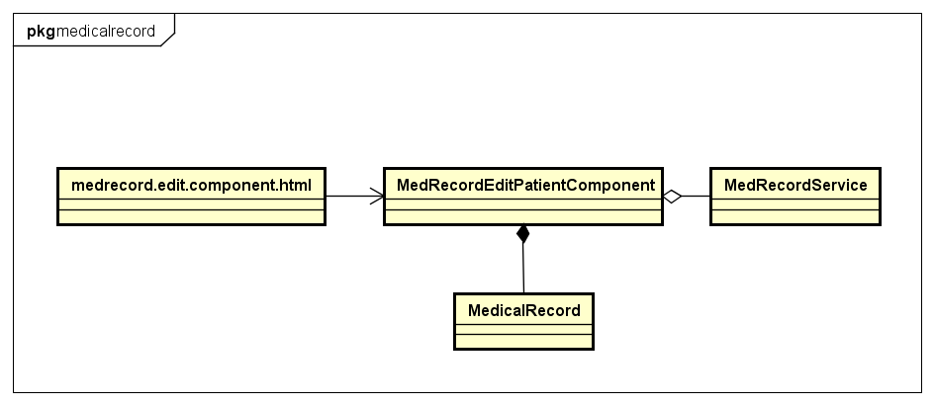

* medrecord.edit.component.html

Refer to UI design

* MedrecordEditPatientComponent

|  |  |  |  |
| --- | --- | --- | --- |
| **Attribute** | | | |
| No. | Name | Type | Description |
| 1 | model | MedicalRecord | Store new data for medical record |
| 2 | medicalRecord | MedicalRecord | Store current medical record |
| 3 | medCategories | MedicalCategory | Store list of medical categories |
| 4 | savingMedicalRecord | boolean | Indicate data is saving |
| 5 | medrecordForm | FormGroup | FormGroup instance for creating medical record |
| 6 | medForms | FormGroup[] | FormGroup instances for creating medicine |
| 7 | submitAttempt | boolean | Indicate user pressed submit button |
| 8 | validFormAdd | boolean | Indicate data is valid |
| 9 | showLoader | boolean | Indicate current medical record is being loaded |

|  |  |  |  |  |
| --- | --- | --- | --- | --- |
| **Method** | | | | |
| No. | Name | Params | Return type | Description |
| 1 | saveMedicalRecord | data: any | boolean | Update new data for medical record |

* MerecordService

|  |  |  |  |
| --- | --- | --- | --- |
| **Attribute** | | | |
| No. | Name | Type | Description |

|  |  |  |  |  |
| --- | --- | --- | --- | --- |
| **Method** | | | | |
| No. | Name | Params | Return type | Description |
| 1 | editMedicalRecord | account: Account,  model: MedicalRecord | Observable | Send request to edit medical record |

* MedicalRecord

|  |  |  |  |
| --- | --- | --- | --- |
| **Attribute** | | | |
| No. | Name | Type | Description |
| 1 | id | string | Identity for medical record |
| 2 | owner | Account | Owner of medical record |
| 3 | creator | Account | Person who created this medical record |
| 4 | category | MedicalCategory | Medical category of medical record |
| 5 | name | string | Name of medical record |
| 6 | date | string | Date of medical record |
| 7 | info | Object | Specific information of patient |
| 8 | created | string | Time at medical record created |
| 9 | lastModified | string | Last time at medical record modified |

|  |  |  |  |  |
| --- | --- | --- | --- | --- |
| **Method** | | | | |
| No. | Name | Params | Return type | Description |

## Delete medical record

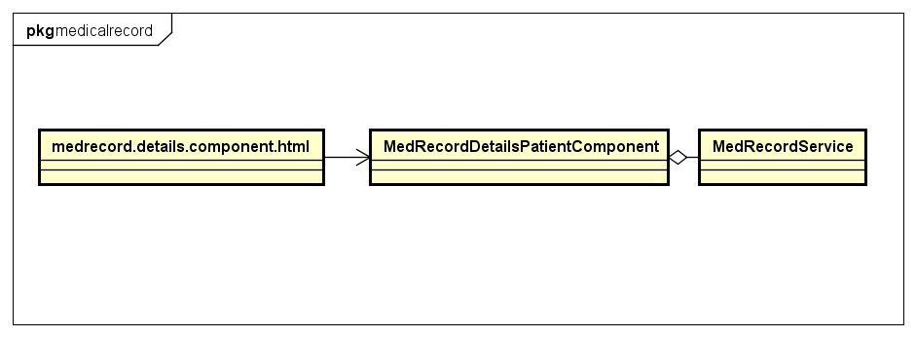

* Medrecord.details.component.html

Refer to UI design

* MedrecordDetailsPatientComponent

|  |  |  |  |
| --- | --- | --- | --- |
| **Attribute** | | | |
| No. | Name | Type | Description |

|  |  |  |  |  |
| --- | --- | --- | --- | --- |
| **Method** | | | | |
| No. | Name | Params | Return type | Description |
| 1 | deleteMedicalRecord |  | void | Delete medical record |

* MedRecordService

|  |  |  |  |
| --- | --- | --- | --- |
| **Attribute** | | | |
| No. | Name | Type | Description |

|  |  |  |  |  |
| --- | --- | --- | --- | --- |
| **Method** | | | | |
| No. | Name | Params | Return type | Description |
| 1 | deleteMedicalRecord | account: Account,  medicalRecordID: string | Observable | Delete medical record |

## View medical notes

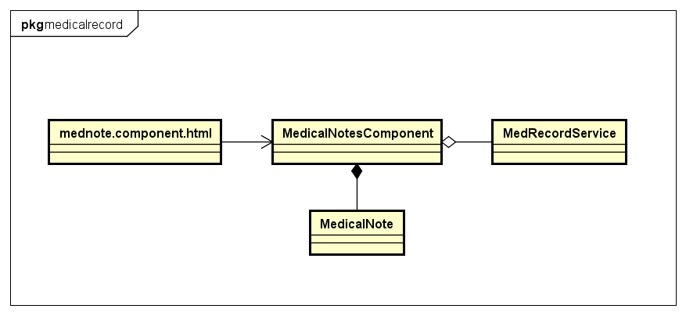

1. mednote.component.html

Refer to UI design

1. MedicalNotesComponent

|  |  |  |  |
| --- | --- | --- | --- |
| **Attribute** | | | |
| No. | Name | Type | Description |
| 1 | medicalNotes | MedicalNote[] | Store all medical notes |
| 2 | showMedNotesLoader | boolean | Indicate data is loading |

|  |  |  |  |  |
| --- | --- | --- | --- | --- |
| **Method** | | | | |
| No. | Name | Params | Return type | Description |
| 1 | getMedicalNotes |  | void | Get all medical note in medical record own by patient |

1. MerecordService

|  |  |  |  |
| --- | --- | --- | --- |
| **Attribute** | | | |
| No. | Name | Type | Description |

|  |  |  |  |  |
| --- | --- | --- | --- | --- |
| **Method** | | | | |
| No. | Name | Params | Return type | Description |
| 1 | getAllMedicalNotes | account: Account,  medicalRecordID: string | Observable | Send request to get all medical notes of medical record own by patient |

1. MedicalNote

|  |  |  |  |
| --- | --- | --- | --- |
| **Attribute** | | | |
| No. | Name | Type | Description |
| 1 | id | string | Identity for medical note |
| 2 | owner | Account | Owner of medical note |
| 3 | creator | Account | Person who created this medical note |
| 4 | medicalRecord | MedicalRecord | Medical record of medical note |
| 5 | content | string | Name of medical note |
| 6 | date | string | Date of medical note |
| 7 | created | string | Time at medical note created |
| 8 | lastModified | string | Last time at medical note modified |

|  |  |  |  |  |
| --- | --- | --- | --- | --- |
| **Method** | | | | |
| No. | Name | Params | Return type | Description |

## Create medical note

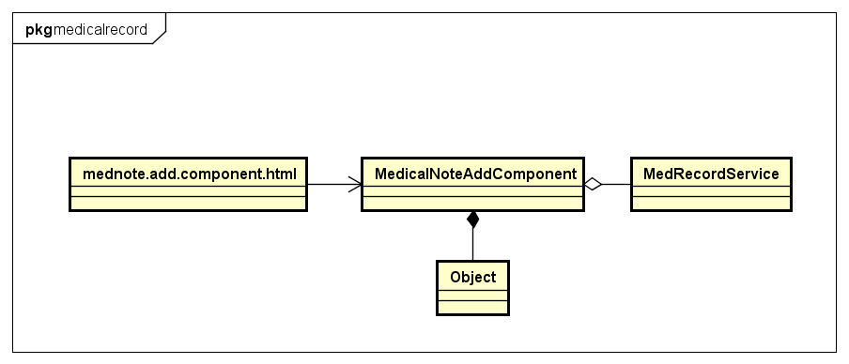

1. mednote.add.component.html

Refer to UI design

1. MedicalNoteAddComponent

|  |  |  |  |
| --- | --- | --- | --- |
| **Attribute** | | | |
| No. | Name | Type | Description |
| 1 | genForm | FormGroup | FormGroup instance for creating medical note |
| 2 | submitAttempt | boolean | Indicate user pressed submit button |
| 3 | savingMedicalNote | boolean | Indicate data is saving |

|  |  |  |  |  |
| --- | --- | --- | --- | --- |
| **Method** | | | | |
| No. | Name | Params | Return type | Description |
| 1 | saveMedicalNote |  | boolean | Save new medical note |

1. MerecordService

|  |  |  |  |
| --- | --- | --- | --- |
| **Attribute** | | | |
| No. | Name | Type | Description |

|  |  |  |  |  |
| --- | --- | --- | --- | --- |
| **Method** | | | | |
| No. | Name | Params | Return type | Description |
| 1 | createMedicalNote | account: Account,  data: Object | Observable | Send request to create medical note |

1. Object (Javascript Object)

## Edit medical note

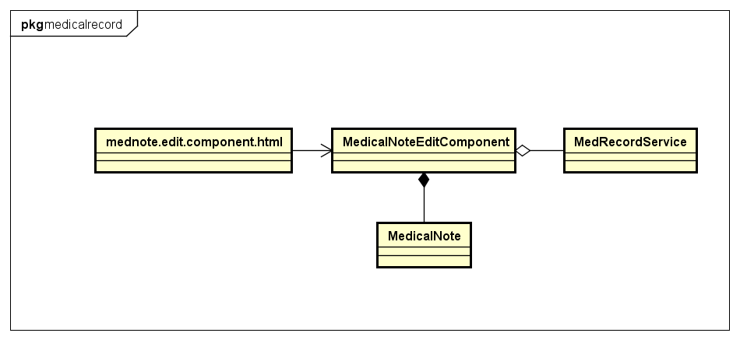

1. mednote.edit.component.html

Refer to UI design

1. MedicalNoteEditComponent

|  |  |  |  |
| --- | --- | --- | --- |
| **Attribute** | | | |
| No. | Name | Type | Description |
| 1 | mednote | MedicalNote | Store all medical notes |
| 2 | savingMedicalNote | boolean | Indicate data is loading |
| 3 | genForm | FormGroup | FormGroup instance for editing medical note. |
| 4 | submitAttempt | boolean | Indicate user pressed submit button |
| 5 | showLoader | boolean | Indicate current medical note is loading |

|  |  |  |  |  |
| --- | --- | --- | --- | --- |
| **Method** | | | | |
| No. | Name | Params | Return type | Description |
| 1 | saveEditMedNote | data: any | boolean | Save new medical note |

1. MerecordService

|  |  |  |  |
| --- | --- | --- | --- |
| **Attribute** | | | |
| No. | Name | Type | Description |

|  |  |  |  |  |
| --- | --- | --- | --- | --- |
| **Method** | | | | |
| No. | Name | Params | Return type | Description |
| 1 | editMedicalNote | account: Account,  data: MedicalNote | Observable | Send request to save new data to medical note |

1. MedicalNote

|  |  |  |  |
| --- | --- | --- | --- |
| **Attribute** | | | |
| No. | Name | Type | Description |
| 1 | id | string | Identity for medical note |
| 2 | owner | Account | Owner of medical note |
| 3 | creator | Account | Person who created this medical note |
| 4 | medicalRecord | MedicalRecord | Medical record of medical note |
| 5 | content | string | Name of medical note |
| 6 | date | string | Date of medical note |
| 7 | created | string | Time at medical note created |
| 8 | lastModified | string | Last time at medical note modified |

|  |  |  |  |  |
| --- | --- | --- | --- | --- |
| **Method** | | | | |
| No. | Name | Params | Return type | Description |

## Delete medical note

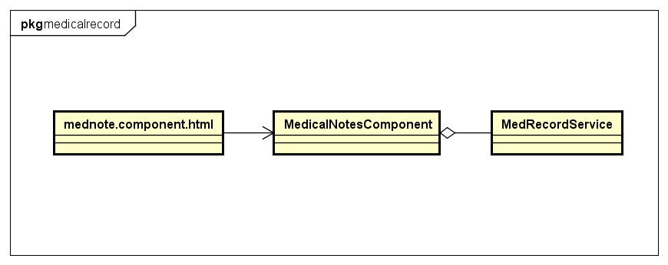

* mednote.component.html

Refer to UI design

* MedicalNotesComponent

|  |  |  |  |
| --- | --- | --- | --- |
| **Attribute** | | | |
| No. | Name | Type | Description |

|  |  |  |  |  |
| --- | --- | --- | --- | --- |
| **Method** | | | | |
| No. | Name | Params | Return type | Description |
| 1 | deleteMedNote | Id: string | void | Delete medical note |

* MedRecordService

|  |  |  |  |
| --- | --- | --- | --- |
| **Attribute** | | | |
| No. | Name | Type | Description |

|  |  |  |  |  |
| --- | --- | --- | --- | --- |
| **Method** | | | | |
| No. | Name | Params | Return type | Description |
| 1 | deleteMedicalNote | account: Account,  id: string | Observable | Delete medical note |

## View medical experiment

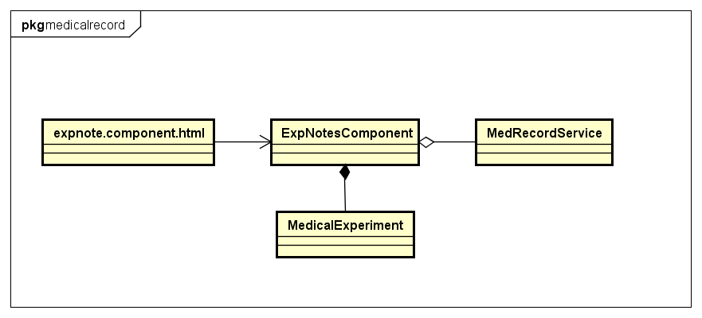

1. expnote.component.html

Refer to UI design

1. ExpNotesComponent

|  |  |  |  |
| --- | --- | --- | --- |
| **Attribute** | | | |
| No. | Name | Type | Description |
| 1 | mednote | MedicalExperiment | Store all medical notes |
| 2 | savingMedicalNote | boolean | Indicate data is loading |
| 3 | genForm | FormGroup | FormGroup instance for editing medical note. |
| 4 | submitAttempt | boolean | Indicate user pressed submit button |
| 5 | showLoader | boolean | Indicate current medical note is loading |

|  |  |  |  |  |
| --- | --- | --- | --- | --- |
| **Method** | | | | |
| No. | Name | Params | Return type | Description |

1. MerecordService

|  |  |  |  |
| --- | --- | --- | --- |
| **Attribute** | | | |
| No. | Name | Type | Description |

|  |  |  |  |  |
| --- | --- | --- | --- | --- |
| **Method** | | | | |
| No. | Name | Params | Return type | Description |
| 1 | getAllMedicalExpriments | account: Account,  medicalRecordID: string | Observable | Send request to get all medical experiment |

1. MedicalExperiment

|  |  |  |  |
| --- | --- | --- | --- |
| **Attribute** | | | |
| No. | Name | Type | Description |
| 1 | id | string | Identity for medical experiment |
| 2 | owner | Account | Owner of medical experiment |
| 3 | creator | Account | Person who created this medical experiment |
| 4 | medicalRecord | MedicalRecord | Medical record of medical experiment |
| 5 | name | string | Name of medical experiment |
| 6 | content | string | Name of medical experiment |
| 7 | time | string | Date of medical experiment |
| 8 | created | string | Time at medical experiment created |
| 9 | lastModified | string | Last time at medical experiment modified |

|  |  |  |  |  |
| --- | --- | --- | --- | --- |
| **Method** | | | | |
| No. | Name | Params | Return type | Description |

## Create medical experiment

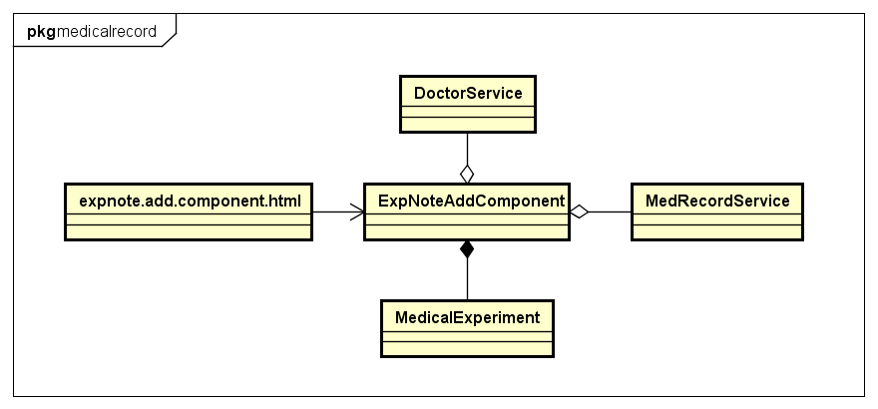

1. Expnote.add.component.html

Refer to UI design

1. ExpNoteAddComponent

|  |  |  |  |
| --- | --- | --- | --- |
| **Attribute** | | | |
| No. | Name | Type | Description |
| 1 | model | MedicalExperiment | Store all medical notes |
| 2 | savingMedicalExp | boolean | Indicate data is loading |
| 3 | genForm | FormGroup | FormGroup instance for creating medical experiment |
| 4 | itemForms | FormGroup[] | FormGroup instances for creating medicines |
| 5 | submitAttempt | boolean | Indicate user pressed submit button |
| 6 | showLoader | boolean | Indicate data is loading |

|  |  |  |  |  |
| --- | --- | --- | --- | --- |
| **Method** | | | | |
| No. | Name | Params | Return type | Description |
| 1 | saveNewExpNote | data: Object | boolean | Create medical experiment |

1. MerecordService

|  |  |  |  |
| --- | --- | --- | --- |
| **Attribute** | | | |
| No. | Name | Type | Description |

|  |  |  |  |  |
| --- | --- | --- | --- | --- |
| **Method** | | | | |
| No. | Name | Params | Return type | Description |
| 1 | createMedicalExperiment | account: Account,  model: MedicalExperiment | Observable | Send request to get all medical notes of medical record own by patient |

1. MedicalExperiment

|  |  |  |  |
| --- | --- | --- | --- |
| **Attribute** | | | |
| No. | Name | Type | Description |
| 1 | id | string | Identity for medical experiment |
| 2 | owner | Account | Owner of medical experiment |
| 3 | creator | Account | Person who created this medical experiment |
| 4 | medicalRecord | MedicalRecord | Medical record of medical experiment |
| 5 | name | string | Name of medical experiment |
| 6 | content | string | Name of medical experiment |
| 7 | time | string | Date of medical experiment |
| 8 | created | string | Time at medical experiment created |
| 9 | lastModified | string | Last time at medical experiment modified |

|  |  |  |  |  |
| --- | --- | --- | --- | --- |
| **Method** | | | | |
| No. | Name | Params | Return type | Description |

## Edit medical experiment

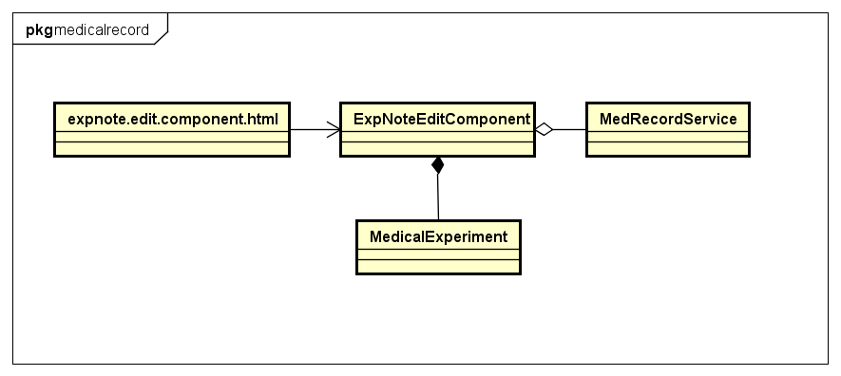

1. expnote.edit.component.html

Refer to UI design

1. ExpNoteEditComponent

|  |  |  |  |
| --- | --- | --- | --- |
| **Attribute** | | | |
| No. | Name | Type | Description |
| 1 | model | MedicalExperiment | Store new data of medical experiment |
| 2 | mednote | MedicalExperiment | Store current data of medical experiment |
| 3 | savingMedicalExp | boolean | Indicate data is loading |
| 4 | genForm | FormGroup | FormGroup instance for editing medical note. |
| 5 | itemForms | FormGroup[] | FormGroup instances for editing medicines |
| 6 | submitAttempt | boolean | Indicate user pressed submit button |
| 7 | showLoader | boolean | Indicate current medical note is loading |

|  |  |  |  |  |
| --- | --- | --- | --- | --- |
| **Method** | | | | |
| No. | Name | Params | Return type | Description |
| 1 | saveExpNote | data: Object | boolean | Save new data for medical experiment |

1. MerecordService

|  |  |  |  |
| --- | --- | --- | --- |
| **Attribute** | | | |
| No. | Name | Type | Description |

|  |  |  |  |  |
| --- | --- | --- | --- | --- |
| **Method** | | | | |
| No. | Name | Params | Return type | Description |
| 1 | editMedicalExperiment | account: Account,  model: MedicalNote | Observable | Send request to save new data to medical note |

1. MedicalExperiment

|  |  |  |  |
| --- | --- | --- | --- |
| **Attribute** | | | |
| No. | Name | Type | Description |
| 1 | id | string | Identity for medical experiment |
| 2 | owner | Account | Owner of medical experiment |
| 3 | creator | Account | Person who created this medical experiment |
| 4 | medicalRecord | MedicalRecord | Medical record of medical experiment |
| 5 | name | string | Name of medical experiment |
| 6 | content | string | Name of medical experiment |
| 7 | time | string | Date of medical experiment |
| 8 | created | string | Time at medical experiment created |
| 9 | lastModified | string | Last time at medical experiment modified |

|  |  |  |  |  |
| --- | --- | --- | --- | --- |
| **Method** | | | | |
| No. | Name | Params | Return type | Description |

## Delete medical experiment

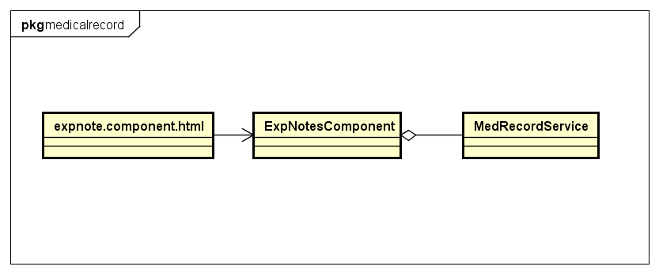

* expnote.component.html

Refer to UI design

* ExpNotesComponent

|  |  |  |  |
| --- | --- | --- | --- |
| **Attribute** | | | |
| No. | Name | Type | Description |

|  |  |  |  |  |
| --- | --- | --- | --- | --- |
| **Method** | | | | |
| No. | Name | Params | Return type | Description |
| 1 | deleteMedicalRecord |  | void | Delete medical record |

* MedRecordService

|  |  |  |  |
| --- | --- | --- | --- |
| **Attribute** | | | |
| No. | Name | Type | Description |

|  |  |  |  |  |
| --- | --- | --- | --- | --- |
| **Method** | | | | |
| No. | Name | Params | Return type | Description |
| 1 | deleteMedicalRecord | account: Account,  medicalRecordID: string | Observable | Delete medical record |

## View medical experiment index

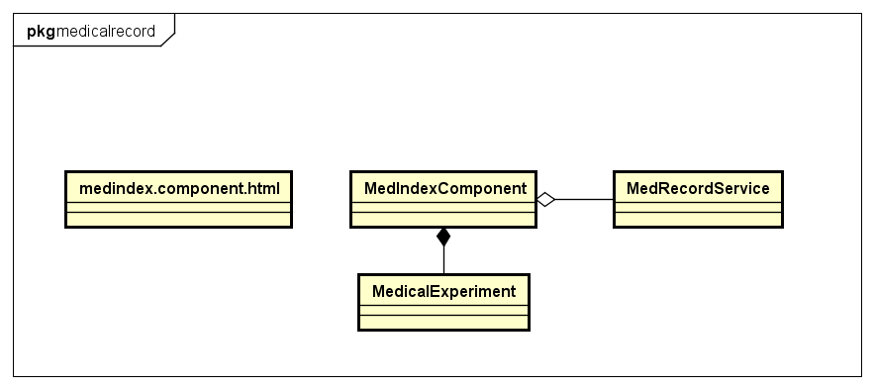

1. medindex.component.html

Refer to UI design

1. MedIndexComponent

|  |  |  |  |
| --- | --- | --- | --- |
| **Attribute** | | | |
| No. | Name | Type | Description |
| 1 | medicalExps | MedicalExperiment[] | Store all medical experiment |

|  |  |  |  |  |
| --- | --- | --- | --- | --- |
| **Method** | | | | |
| No. | Name | Params | Return type | Description |

1. MerecordService

|  |  |  |  |
| --- | --- | --- | --- |
| **Attribute** | | | |
| No. | Name | Type | Description |

|  |  |  |  |  |
| --- | --- | --- | --- | --- |
| **Method** | | | | |
| No. | Name | Params | Return type | Description |
| 1 | getAllMedicalExpriments | account: Account,  medicalRecordID: string | Observable | Send request to get all medical experiment of specific medical record |

1. MedicalExperiment

|  |  |  |  |
| --- | --- | --- | --- |
| **Attribute** | | | |
| No. | Name | Type | Description |
| 1 | id | string | Identity for medical experiment |
| 2 | owner | Account | Owner of medical experiment |
| 3 | creator | Account | Person who created this medical experiment |
| 4 | medicalRecord | MedicalRecord | Medical record of medical experiment |
| 5 | name | string | Name of medical experiment |
| 6 | content | string | Name of medical experiment |
| 7 | time | string | Date of medical experiment |
| 8 | created | string | Time at medical experiment created |
| 9 | lastModified | string | Last time at medical experiment modified |

|  |  |  |  |  |
| --- | --- | --- | --- | --- |
| **Method** | | | | |
| No. | Name | Params | Return type | Description |

## View medical record images

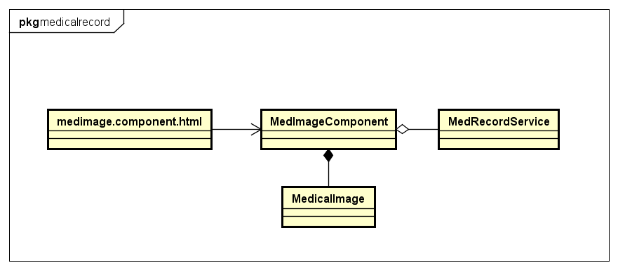

1. medimage.component.html

Refer to UI design

1. MedImageComponent

|  |  |  |  |
| --- | --- | --- | --- |
| **Attribute** | | | |
| No. | Name | Type | Description |
| 1 | medImages | MedicalImage[] | Store all medical images |
| 2 | showMedImgLoader | boolean | Indicate data is loading |

|  |  |  |  |  |
| --- | --- | --- | --- | --- |
| **Method** | | | | |
| No. | Name | Params | Return type | Description |

1. MerecordService

|  |  |  |  |
| --- | --- | --- | --- |
| **Attribute** | | | |
| No. | Name | Type | Description |

|  |  |  |  |  |
| --- | --- | --- | --- | --- |
| **Method** | | | | |
| No. | Name | Params | Return type | Description |
| 1 | getAllMedicalImages | account: Account,  medicalRecordID: string | Observable | Send request to get all medical images of specific medical record |

1. MedicalImage

|  |  |  |  |
| --- | --- | --- | --- |
| **Attribute** | | | |
| No. | Name | Type | Description |
| 1 | id | string | Identity for medical image |
| 2 | owner | Account | Owner of medical image |
| 3 | creator | Account | Person who created this medical image |
| 4 | medicalRecord | MedicalRecord | Medical record of medical image |
| 5 | image64 | string | Store image in base64 |
|  | imageBlob | Blob | Blob instance for image |
| 6 | size | string | Date of medical record |
| 7 | created | string | Time at medical record created |

|  |  |  |  |  |
| --- | --- | --- | --- | --- |
| **Method** | | | | |
| No. | Name | Params | Return type | Description |

## Upload medical record images

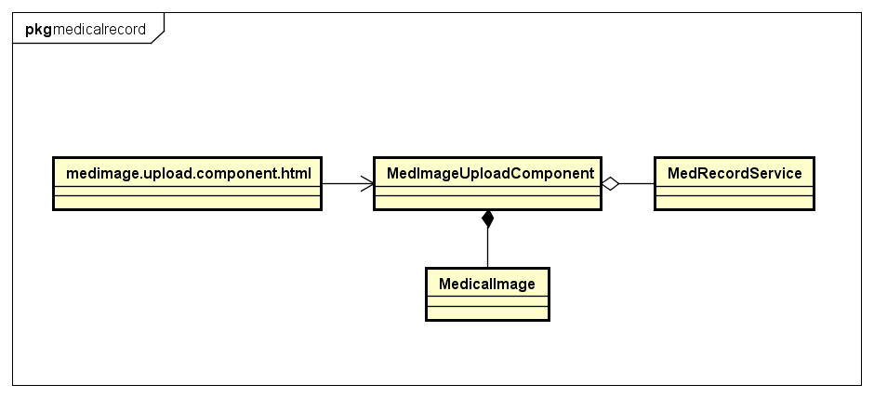

1. medimage.upload.component.html

Refer to UI design

1. MedImageUploadComponent

|  |  |  |  |
| --- | --- | --- | --- |
| **Attribute** | | | |
| No. | Name | Type | Description |
| 1 | medImages | MedicalImage[] | Store all medical images |
| 2 | savingNewImages | boolean | Indicate data is saving |

|  |  |  |  |  |
| --- | --- | --- | --- | --- |
| **Method** | | | | |
| No. | Name | Params | Return type | Description |
| 1 | saveNewImages |  | void | Save new medical image |

1. MerecordService

|  |  |  |  |
| --- | --- | --- | --- |
| **Attribute** | | | |
| No. | Name | Type | Description |

|  |  |  |  |  |
| --- | --- | --- | --- | --- |
| **Method** | | | | |
| No. | Name | Params | Return type | Description |
| 1 | createMedicalImage | account: Account,  data: FormData | Observable | Send request to save new medical image |

1. MedicalImage

|  |  |  |  |
| --- | --- | --- | --- |
| **Attribute** | | | |
| No. | Name | Type | Description |
| 1 | id | string | Identity for medical image |
| 2 | owner | Account | Owner of medical image |
| 3 | creator | Account | Person who created this medical image |
| 4 | medicalRecord | MedicalRecord | Medical record of medical image |
| 5 | image64 | string | Store image in base64 |
|  | imageBlob | Blob | Blob instance for image |
| 6 | size | string | Date of medical record |
| 7 | created | string | Time at medical record created |

|  |  |  |  |  |
| --- | --- | --- | --- | --- |
| **Method** | | | | |
| No. | Name | Params | Return type | Description |

## Delete medical image

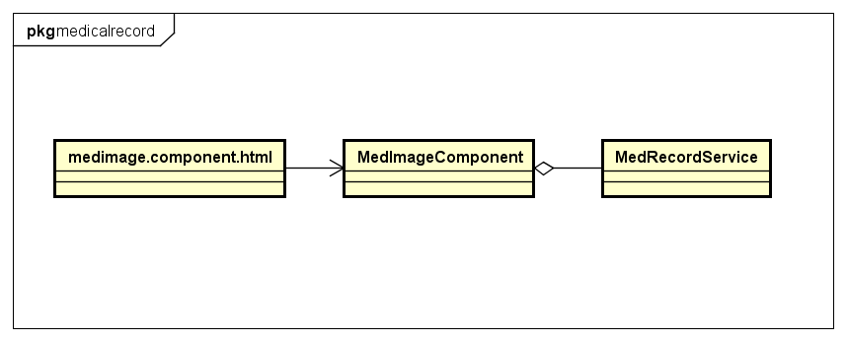

* medimage.component.html

Refer to UI design

* MedImageComponent

|  |  |  |  |
| --- | --- | --- | --- |
| **Attribute** | | | |
| No. | Name | Type | Description |

|  |  |  |  |  |
| --- | --- | --- | --- | --- |
| **Method** | | | | |
| No. | Name | Params | Return type | Description |
| 1 | deleteChosenImageAttachment | Event: any,  Item: MedicalImage | void | Delete medical image |

* MedRecordService

|  |  |  |  |
| --- | --- | --- | --- |
| **Attribute** | | | |
| No. | Name | Type | Description |

|  |  |  |  |  |
| --- | --- | --- | --- | --- |
| **Method** | | | | |
| No. | Name | Params | Return type | Description |
| 1 | deleteMedicalImage | account: Account,  id: string | Observable | Delete medical image |

## Create prescription

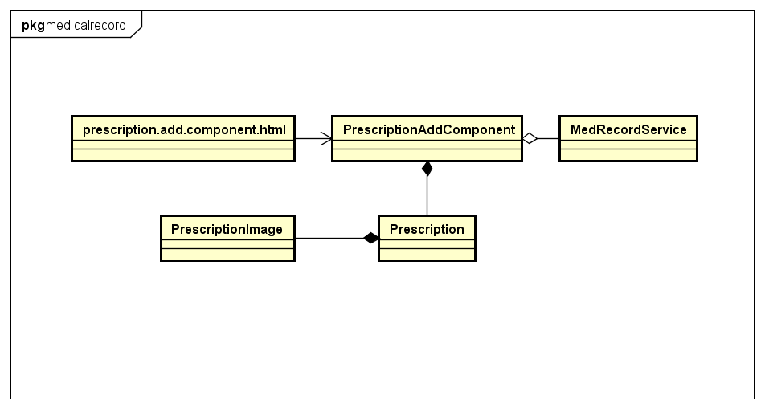

1. prescription.add.component.html

Refer to UI design

1. PrescriptionAddComponent

|  |  |  |  |
| --- | --- | --- | --- |
| **Attribute** | | | |
| No. | Name | Type | Description |
| 1 | prescriptionModel | Prescription | Store data of prescription |
| 2 | presImgs | PrescriptionImage[] | Store all image of prescription |
| 3 | genForm | FormGroup | FormGroup instance for creating prescription |
| 4 | medForm | FormGroup | FormGroup instance for medicines |
| 5 | savingPrescription | boolean | Indicate prescription is saving |

|  |  |  |  |  |
| --- | --- | --- | --- | --- |
| **Method** | | | | |
| No. | Name | Params | Return type | Description |
| 1 | savePrescription |  | void | Save prescription |

1. MerecordService

|  |  |  |  |
| --- | --- | --- | --- |
| **Attribute** | | | |
| No. | Name | Type | Description |

|  |  |  |  |  |
| --- | --- | --- | --- | --- |
| **Method** | | | | |
| No. | Name | Params | Return type | Description |
| 1 | createPrescription | account: Account,  data: Prescription | Observable | Send request to save new data to medical note |
| 2 | createPrescriptionImage | account: Account,  data: FormData | Observable | Send request to save prescription image |

1. Prescription

|  |  |  |  |
| --- | --- | --- | --- |
| **Attribute** | | | |
| No. | Name | Type | Description |
| 1 | id | string | Identity for prescription |
| 2 | owner | Account | Owner of prescription |
| 3 | creator | Account | Person who created this prescription |
| 4 | medicalRecord | MedicalRecord | Medical record of prescription |
| 5 | name | string | Name of prescription |
| 6 | from | string | Date of prescription |
| 7 | to | string | Time at prescription created |
| 8 | medicine | Object | Last time at prescription modified |
| 9 | imgArr | PrescriptionImage[] | Images of prescription |
| 10 | note | string | Note for prescription |
| 11 | created | string | Time at prescription created |
| 12 | lastModified | string | Last time prescription modified |

|  |  |  |  |  |
| --- | --- | --- | --- | --- |
| **Method** | | | | |
| No. | Name | Params | Return type | Description |

5. PrescriptionImage

|  |  |  |  |
| --- | --- | --- | --- |
| **Attribute** | | | |
| No. | Name | Type | Description |
| 1 | id | string | Identity for prescription |
| 2 | owner | Account | Owner of prescription |
| 3 | creator | Account | Person who created this prescription |
| 4 | prescription | Prescription | Medical record of prescription |
| 5 | image64 | string | Base64 format of image |
| 6 | imageBlob | Blob | Blob format of image |
| 7 | removed | boolean | Indicate image should be removed |
| 8 | size | string | True size of image |
| 9 | created | string | Time at prescription created |

|  |  |  |  |  |
| --- | --- | --- | --- | --- |
| **Method** | | | | |
| No. | Name | Params | Return type | Description |

## View prescriptions

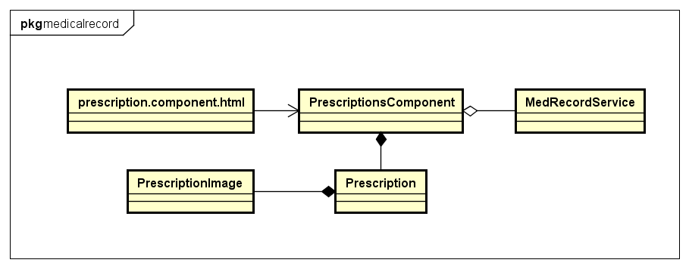

1. prescription.component.html

Refer to UI design

1. PrescriptionsComponent

|  |  |  |  |
| --- | --- | --- | --- |
| **Attribute** | | | |
| No. | Name | Type | Description |
| 1 | prescriptions | Prescription[] | Store date of prescription |
| 2 | showLoader | PrescriptionImage[] | Indicate data of prescription is loading |
| 3 | showImgLoader | FormGroup | Indicate image for prescription is loading |

|  |  |  |  |  |
| --- | --- | --- | --- | --- |
| **Method** | | | | |
| No. | Name | Params | Return type | Description |

1. MerecordService

|  |  |  |  |
| --- | --- | --- | --- |
| **Attribute** | | | |
| No. | Name | Type | Description |

|  |  |  |  |  |
| --- | --- | --- | --- | --- |
| **Method** | | | | |
| No. | Name | Params | Return type | Description |
| 1 | getAllPrescriptions | account: Account,  medicalRecordID: string | Observable | Send request to get all prescription own by patient |

1. Prescription

|  |  |  |  |
| --- | --- | --- | --- |
| **Attribute** | | | |
| No. | Name | Type | Description |
| 1 | id | string | Identity for prescription |
| 2 | owner | Account | Owner of prescription |
| 3 | creator | Account | Person who created this prescription |
| 4 | medicalRecord | MedicalRecord | Medical record of prescription |
| 5 | name | string | Name of prescription |
| 6 | from | string | Date of prescription |
| 7 | to | string | Time at prescription created |
| 8 | medicine | Object | Last time at prescription modified |
| 9 | imgArr | PrescriptionImage[] | Images of prescription |
| 10 | note | string | Note for prescription |
| 11 | created | string | Time at prescription created |
| 12 | lastModified | string | Last time prescription modified |

|  |  |  |  |  |
| --- | --- | --- | --- | --- |
| **Method** | | | | |
| No. | Name | Params | Return type | Description |

5. PrescriptionImage

|  |  |  |  |
| --- | --- | --- | --- |
| **Attribute** | | | |
| No. | Name | Type | Description |
| 1 | id | string | Identity for prescription |
| 2 | owner | Account | Owner of prescription |
| 3 | creator | Account | Person who created this prescription |
| 4 | prescription | Prescription | Medical record of prescription |
| 5 | image64 | string | Base64 format of image |
| 6 | imageBlob | Blob | Blob format of image |
| 7 | removed | boolean | Indicate image should be removed |
| 8 | size | string | True size of image |
| 9 | created | string | Time at prescription created |

|  |  |  |  |  |
| --- | --- | --- | --- | --- |
| **Method** | | | | |
| No. | Name | Params | Return type | Description |

## Edit prescription

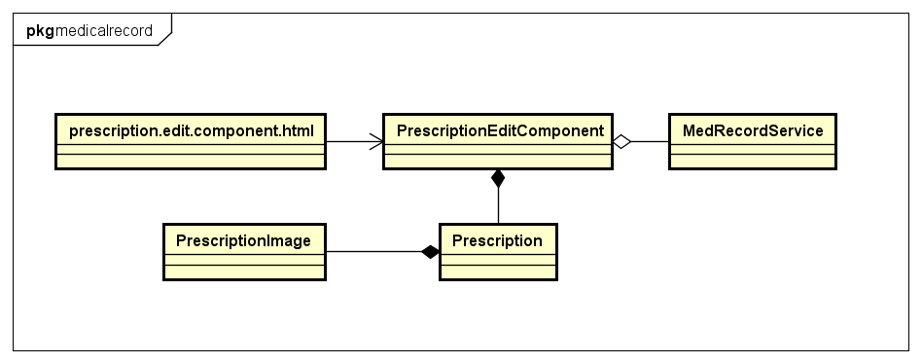

1. prescription.edit.component.html

Refer to UI design

1. PrescriptionEditComponent

|  |  |  |  |
| --- | --- | --- | --- |
| **Attribute** | | | |
| No. | Name | Type | Description |
| 1 | prescriptionModel | Prescription | Store data of prescription |
| 2 | prescription | Prescription | Store current data of prescription |
| 3 | editPreOldImgs | PrescriptionImage[] | Store all current image of prescription |
| 4 | editPreImgs | PrescriptionImage[] | Store all newly uploaded image of prescription |
| 5 | genForm | FormGroup | FormGroup instance for editing prescription |
| 6 | medForm | FormGroup | FormGroup instance for medicines |
| 7 | savingPrescription | boolean | Indicate prescription is saving |

|  |  |  |  |  |
| --- | --- | --- | --- | --- |
| **Method** | | | | |
| No. | Name | Params | Return type | Description |
| 1 | savePrescription |  | void | Save prescription |

1. MerecordService

|  |  |  |  |
| --- | --- | --- | --- |
| **Attribute** | | | |
| No. | Name | Type | Description |

|  |  |  |  |  |
| --- | --- | --- | --- | --- |
| **Method** | | | | |
| No. | Name | Params | Return type | Description |
| 1 | editPrescription | account: Account,  prescriptionModel: Prescription | Observable | Send request to save new data to medical note |
| 2 | createPrescriptionImage | account: Account,  data: FormData | Observable | Send request to save prescription image |
| 3 | deletePrescriptionImage | account: Account,  id: string | Observable | Send request to remove image |

1. Prescription

|  |  |  |  |
| --- | --- | --- | --- |
| **Attribute** | | | |
| No. | Name | Type | Description |
| 1 | id | string | Identity for prescription |
| 2 | owner | Account | Owner of prescription |
| 3 | creator | Account | Person who created this prescription |
| 4 | medicalRecord | MedicalRecord | Medical record of prescription |
| 5 | name | string | Name of prescription |
| 6 | from | string | Date of prescription |
| 7 | to | string | Time at prescription created |
| 8 | medicine | Object | Last time at prescription modified |
| 9 | imgArr | PrescriptionImage[] | Images of prescription |
| 10 | note | string | Note for prescription |
| 11 | created | string | Time at prescription created |
| 12 | lastModified | string | Last time prescription modified |

|  |  |  |  |  |
| --- | --- | --- | --- | --- |
| **Method** | | | | |
| No. | Name | Params | Return type | Description |

5. PrescriptionImage

|  |  |  |  |
| --- | --- | --- | --- |
| **Attribute** | | | |
| No. | Name | Type | Description |
| 1 | id | string | Identity for prescription |
| 2 | owner | Account | Owner of prescription |
| 3 | creator | Account | Person who created this prescription |
| 4 | prescription | Prescription | Medical record of prescription |
| 5 | image64 | string | Base64 format of image |
| 6 | imageBlob | Blob | Blob format of image |
| 7 | removed | boolean | Indicate image should be removed |
| 8 | size | string | True size of image |
| 9 | created | string | Time at prescription created |

|  |  |  |  |  |
| --- | --- | --- | --- | --- |
| **Method** | | | | |
| No. | Name | Params | Return type | Description |

## Delete prescription

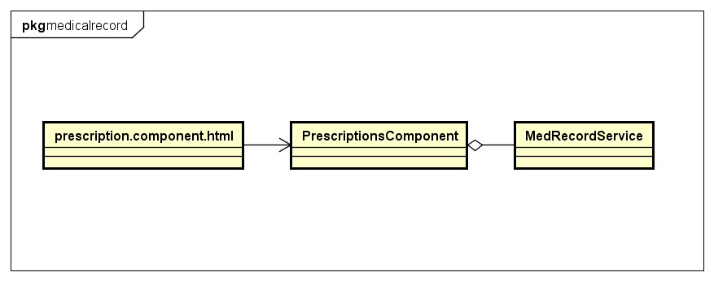

* prescription.component.html

Refer to UI design

* PrescriptionComponent

|  |  |  |  |
| --- | --- | --- | --- |
| **Attribute** | | | |
| No. | Name | Type | Description |

|  |  |  |  |  |
| --- | --- | --- | --- | --- |
| **Method** | | | | |
| No. | Name | Params | Return type | Description |
| 1 | deletePrescription | Id: string | void | Delete prescription |

* MedRecordService

|  |  |  |  |
| --- | --- | --- | --- |
| **Attribute** | | | |
| No. | Name | Type | Description |

|  |  |  |  |  |
| --- | --- | --- | --- | --- |
| **Method** | | | | |
| No. | Name | Params | Return type | Description |
| 1 | deletePrescription | account: Account,  id: string | Observable | Delete prescription |

## Manage allergy

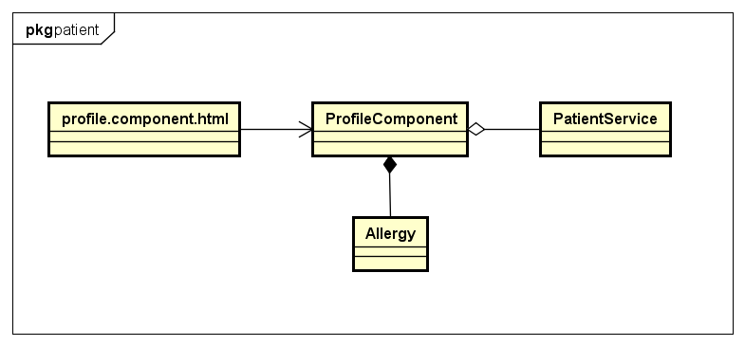

1. profile.component.html

Refer to UI design

1. ProfileComponent

|  |  |  |  |
| --- | --- | --- | --- |
| **Attribute** | | | |
| No. | Name | Type | Description |
| 1 | allergies | Allergy[] | Store list of allergies |
|  | addAllergyForm | FormGroup | FromGroup instance for creating form |
|  | editAllergyForm | FormGroup | FormGroup instance for editing form |

|  |  |  |  |  |
| --- | --- | --- | --- | --- |
| **Method** | | | | |
| No. | Name | Params | Return type | Description |
| 1 | deleteAllergy | Item:Allergy | Void | Delete an allergy |
| 2 | saveEditAllergy | data: any | Boolean | Update an allergy |
| 3 | saveNewAllergy | data: any | boolean | Create an allergy |

1. PatientService

|  |  |  |  |
| --- | --- | --- | --- |
| **Attribute** | | | |
| No. | Name | Type | Description |

|  |  |  |  |  |
| --- | --- | --- | --- | --- |
| **Method** | | | | |
| No. | Name | Params | Return type | Description |
| 1 | getAllAllergies | account: Account | Observable | Send request to get allergies |
| 2 | deleteAllergy | account: Account, id: string | Observable | Send request to delete allergy |
| 3 | updateAllergy | account: Account, data: any | Observable | Send request to update allergy |
| 4 | createNewAllergy | account: Account, data: any | Observable | Send request to create allergy |

1. Allergy

|  |  |  |  |
| --- | --- | --- | --- |
| **Attribute** | | | |
| No. | Name | Type | Description |
|  | Id | string | Identify for medical allergy |
|  | account | Account | Account who has allergy |
|  | name | string | name of allergy |
|  | cause | string | cause of allergy |
|  | note | string | note of allergy |
|  | created | string | Time at allergy is created |
|  | lastModified | string | Last time allergy is modified |

|  |  |  |  |  |
| --- | --- | --- | --- | --- |
| **Method** | | | | |
| No. | Name | Params | Return type | Description |

## Manage addiction

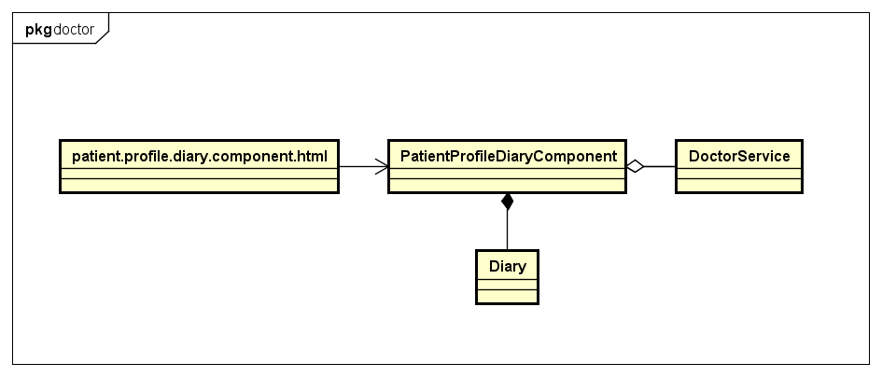

1. patient.profile.diary.component.html

Refer to UI design

1. PatientProfileDiraryComponent

|  |  |  |  |
| --- | --- | --- | --- |
| **Attribute** | | | |
| No. | Name | Type | Description |
| 1 | addictions | Addiction[] | Store list of medical records |
| 2 | addAddictionForm | FormGroup | FormGroup instance for adding addiction |
| 3 | editAddictionForm | FormGroup | FormGroup instance for editing addiction |

|  |  |  |  |  |
| --- | --- | --- | --- | --- |
| **Method** | | | | |
| No. | Name | Params | Return type | Description |
| 1 | saveNewAddiction | data: any | boolean | Create addiction |
| 2 | saveEditAddiction | data: any | boolean | Update addiction |
| 3 | deleteAddiction | Item: Addiction | void | Delete addiction |

1. PatientService

|  |  |  |  |
| --- | --- | --- | --- |
| **Attribute** | | | |
| No. | Name | Type | Description |

|  |  |  |  |  |
| --- | --- | --- | --- | --- |
| **Method** | | | | |
| No. | Name | Params | Return type | Description |
| 1 | getAllAddictions | account: Account | Observable | Send request to get diary |
| 2 | createNewAddiction | account: Account,  data: any | Observable | Send request to create addiction |
| 3 | updateAddiction | account: Account,  data: any | Observable | Send request to update addiction |
| 4 | deleteAddiction | account: Account,  id: string | Observable | Send request to delete an adddiction |

1. Addiction

|  |  |  |  |
| --- | --- | --- | --- |
| **Attribute** | | | |
| No. | Name | Type | Description |
|  | Id | string | Identify for addiction |
|  | account | Account | Account who has addiction |
|  | cause | string | Name of addiction |
|  | note | string | Note of addiction |
|  | created | string | Time at addiction is created |
|  | lastModified | string | Last time addiction is modified |

|  |  |  |  |  |
| --- | --- | --- | --- | --- |
| **Method** | | | | |
| No. | Name | Params | Return type | Description |

## Manage bloodpressure records

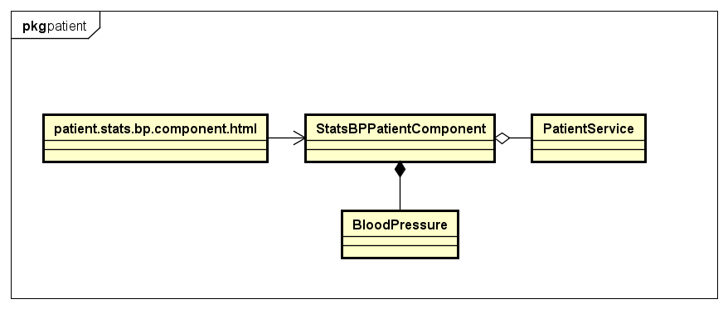

1. patient.stats.bp.component.html

Refer to UI design

1. StatsBPPatientComponent

|  |  |  |  |
| --- | --- | --- | --- |
| **Attribute** | | | |
| No. | Name | Type | Description |
| 1 | bloodPressureList | BloodPressure[] | Store list of blood pressure records |
| 2 | addForm | FormGroup | FormGroup instance for adding blood pressure record |
| 3 | editForm | FormGroup | FormGroup instance for editing blood pressure record |

|  |  |  |  |  |
| --- | --- | --- | --- | --- |
| **Method** | | | | |
| No. | Name | Params | Return type | Description |
| 1 | saveNewBloodPressure | data: any | boolean | Create blood pressure record |
| 2 | saveEditBloodPressure | data: any | boolean | Update blood pressure record |
| 3 | deleteBPItem | Item: BloodPressure | boolean | Delete blood pressure record |

1. PatientService

|  |  |  |  |
| --- | --- | --- | --- |
| **Attribute** | | | |
| No. | Name | Type | Description |

|  |  |  |  |  |
| --- | --- | --- | --- | --- |
| **Method** | | | | |
| No. | Name | Params | Return type | Description |
| 1 | getAllBloodPressureRecords | account: Account | Observable | Send request to get all blood pressure records |
| 2 | createBloodpressure | account: Account,  data: any | Observable | Send request to create blood pressure record |
| 3 | editBloodPresssure | account: Account,  data: any | Observable | Send request to edit blood pressure record |
| 4 | deleteBloodPressure | account: Account,  id: string | Observable | Send request to delete blood pressure record |

1. BloodPressure

|  |  |  |  |
| --- | --- | --- | --- |
| **Attribute** | | | |
| No. | Name | Type | Description |
| 1 | id | string | Identity |
| 2 | diastole | number | Diastole value |
| 3 | systole | number | Systole value |
| 4 | note | string | Note for record |
| 5 | time | string | Time for record |
| 6 | created | string | Time at record created |

|  |  |  |  |  |
| --- | --- | --- | --- | --- |
| **Method** | | | | |
| No. | Name | Params | Return type | Description |

## View blood sugar

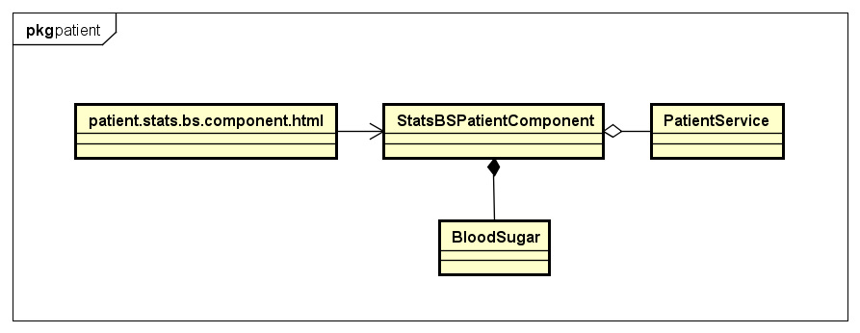

1. patient.stats.bs.component.html

Refer to UI design

1. StatsBSPatientComponent

|  |  |  |  |
| --- | --- | --- | --- |
| **Attribute** | | | |
| No. | Name | Type | Description |
| 1 | bloodSugarList | BloodSugar[] | Store list of blood sugar records |
| 2 | addForm | FormGroup | FormGroup instance for adding record |
| 3 | editForm | FormGroup | FormGroup instance for editing record |

|  |  |  |  |  |
| --- | --- | --- | --- | --- |
| **Method** | | | | |
| No. | Name | Params | Return type | Description |
| 1 | saveNewBloodSugar | data: any | booelan | Create blood sugar record |
| 2 | saveEditBloodSugar | data: any | boolean | Update blood sugar record |
| 3 | deleteBSItem | item: BloodSugar | boolean | Delete blood sugar record |

1. PatientService

|  |  |  |  |
| --- | --- | --- | --- |
| **Attribute** | | | |
| No. | Name | Type | Description |

|  |  |  |  |  |
| --- | --- | --- | --- | --- |
| **Method** | | | | |
| No. | Name | Params | Return type | Description |
| 1 | getAllBloodSugarRecords | account: Account | Observable | Send request to get all blood sugar records |
| 2 | createBloodSugar | account: Account,  data: any | Observable | Send request to create blood sugar record |
| 3 | editBloodSugar | account: Account,  data: any | Observable | Send request to edit blood sugar record |
| 4 | deleteBloodSugar | account: Account,  id: string | Observable | Send request to delete blood sugar record |

1. BloodSugar

|  |  |  |  |
| --- | --- | --- | --- |
| **Attribute** | | | |
| No. | Name | Type | Description |
| 1 | id | string | Identity |
| 2 | value | number | Value for record |
| 3 | Note | string | note of diary |
| 4 | time | string | Time at record is measured |
| 8 | created | string | Time at record item created |

|  |  |  |  |  |
| --- | --- | --- | --- | --- |
| **Method** | | | | |
| No. | Name | Params | Return type | Description |

## View heartbeat

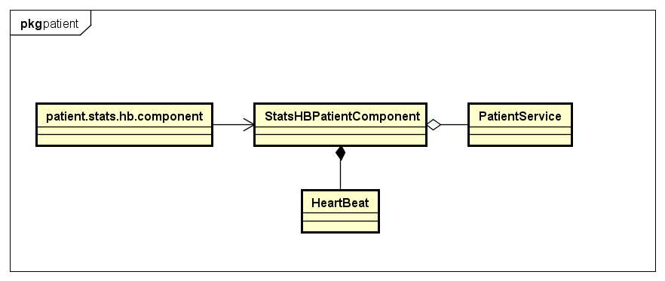

1. patient.stats.hb.component.html

Refer to UI design

1. StatsHBPatientComponent

|  |  |  |  |
| --- | --- | --- | --- |
| **Attribute** | | | |
| No. | Name | Type | Description |
| 1 | heartbeatList | HeartBeat[] | Store list of heartbeat records |
| 2 | addForm | FormGroup | FormGroup instance for adding heartbeat record |
| 3 | editForm | FormGroup | FormGroup instance for editing heartbeat record |

|  |  |  |  |  |
| --- | --- | --- | --- | --- |
| **Method** | | | | |
| No. | Name | Params | Return type | Description |
| 1 | saveNewHeartBeat | data: any | boolean |  |
| 2 | saveEditHeartBeat | data: any | Boolean |  |
| 3 | deleteHBItem | Item: HeartBeat | void |  |

1. PatientService

|  |  |  |  |
| --- | --- | --- | --- |
| **Attribute** | | | |
| No. | Name | Type | Description |

|  |  |  |  |  |
| --- | --- | --- | --- | --- |
| **Method** | | | | |
| No. | Name | Params | Return type | Description |
| 1 | getAllHeartBeatRecords | account: Account | Observable | Send request to get all heartbeat records |
| 2 | createHeartBeat | account: Account,  data: any | Observable | Send request to create heartbeat record |
| 3 | editHeartBeat | account: Account,  data: any | Observable | Send request to edit heartbeat record |
| 4 | deleteHeartBeat | account: Account,  id: string | Observable | Send request to delete heartbeat record |

1. HeartBeat

|  |  |  |  |
| --- | --- | --- | --- |
| **Attribute** | | | |
| No. | Name | Type | Description |
| 1 | id | string | Identity |
| 2 | rate | Account | Rate value |
| 3 | note | string | Note of record |
| 4 | time | string | Time when record is measured |
| 8 | created | string | Time record created |

|  |  |  |  |  |
| --- | --- | --- | --- | --- |
| **Method** | | | | |
| No. | Name | Params | Return type | Description |

## View doctor’s profile

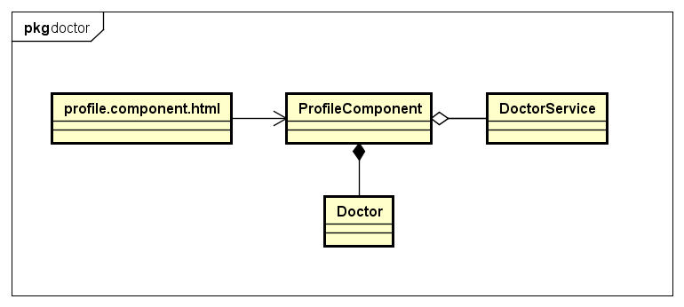

* profile.component.html

Refer to UI design

* ProfileComponent

|  |  |  |  |
| --- | --- | --- | --- |
| **Attribute** | | | |
| No. | Name | Type | Description |
| 1 | doctor | Doctor | Store current doctor profile |

|  |  |  |  |  |
| --- | --- | --- | --- | --- |
| **Method** | | | | |
| No. | Name | Params | Return type | Description |
| 1 | handleDoctorConnection |  | void | Send request/ Remove request relationship based on context |
| 2 | saveComment | data: any | void | Rate a doctor |

* DoctorService

|  |  |  |  |
| --- | --- | --- | --- |
| **Attribute** | | | |
| No. | Name | Type | Description |

|  |  |  |  |  |
| --- | --- | --- | --- | --- |
| **Method** | | | | |
| No. | Name | Params | Return type | Description |
| 1 | getDoctorProfile | account: Account,  doctorID: string | Observable | Send request to update photo |
| 2 | getAllComments | account: Account,  doctorID: string | Observable | Send request to get all comments |
| 3 | deleteReqRelationship | account: Account,  relID: string | Observable | Send request to delete relationship request |
| 4 | sendReqRelationship | account: Account,  doctorID: string,  message: string | Observable | Send request to send relationship request |
| 5 | createComment | account: Account,  data: any, | Observable | Send request to add rating to doctor |

* Doctor

|  |  |  |  |
| --- | --- | --- | --- |
| **Attribute** | | | |
| No. | Name | Type | Description |
|  | Id | string | Identify for doctor |
|  | firstName | string | First name of doctor |
|  | lastName | string | Last name of doctor |
|  | fullname | string | Full name of doctor |
|  | email | string | Email of doctor |
|  | password | string | Password of doctor |
|  | dob | string | Day of birth |
|  | sex | number | Sex of doctor |
|  | phone | string | Phone of doctor |
|  | role | number | Role of doctor in system |
|  | status | number | Status of doctor’s account |
|  | address | string | Address of doctor |
|  | photo | string | Photo of doctor |
|  | created | string | Time at doctor account created |
|  | lastModified | string | Last time doctor account is modified |
|  | rank | number | Rank of doctor |
|  | specialty | Specialty | Specialty of doctor |
|  | place | Place | Place where doctor work |
|  | noOfVoters | Number | Number of patient who commented |
|  | attachment | string | Attachment of doctor |

|  |  |  |  |  |
| --- | --- | --- | --- | --- |
| **Method** | | | | |
| No. | Name | Params | Return type | Description |

## View profile

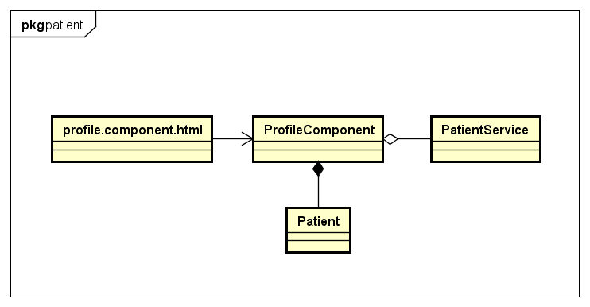

1. profile.component.html

Refer to UI design

1. ProfileComponent

|  |  |  |  |
| --- | --- | --- | --- |
| **Attribute** | | | |
| No. | Name | Type | Description |
| 1 | patient | Patient | Store patient information |

|  |  |  |  |  |
| --- | --- | --- | --- | --- |
| **Method** | | | | |
| No. | Name | Params | Return type | Description |

1. PatientService

|  |  |  |  |
| --- | --- | --- | --- |
| **Attribute** | | | |
| No. | Name | Type | Description |

|  |  |  |  |  |
| --- | --- | --- | --- | --- |
| **Method** | | | | |
| No. | Name | Params | Return type | Description |
| 1 | getPatientProfile | account: Account,  patientID: string | Observable | Send request to get patient details |

1. Patient

|  |  |  |  |
| --- | --- | --- | --- |
| **Attribute** | | | |
| No. | Name | Type | Description |
|  | Id | string | Identify for medical category item |
|  | firstName | string | First name of patient |
|  | lastName | string | Last name of patient |
|  | fullname | string | Full name of patient |
|  | email | string | Email of patient |
|  | password | string | Password of patient |
|  | dob | string | Day of birth |
|  | sex | number | Sex of patient |
|  | phone | string | Phone of patient |
|  | role | number | Role of patient in system |
|  | status | number | Status of patient’s account |
|  | address | string | Address of patient |
|  | photo | string | Photo of patient |
|  | created | string | Time at patient account is created |
|  | lastModified | string | Last time patient account is modified |
|  | weight | number | weight of patient |
|  | height | number | height of patient |

|  |  |  |  |  |
| --- | --- | --- | --- | --- |
| **Method** | | | | |
| No. | Name | Params | Return type | Description |